Beltway Trainer: Informed Consent Form for Physical Fitness Program
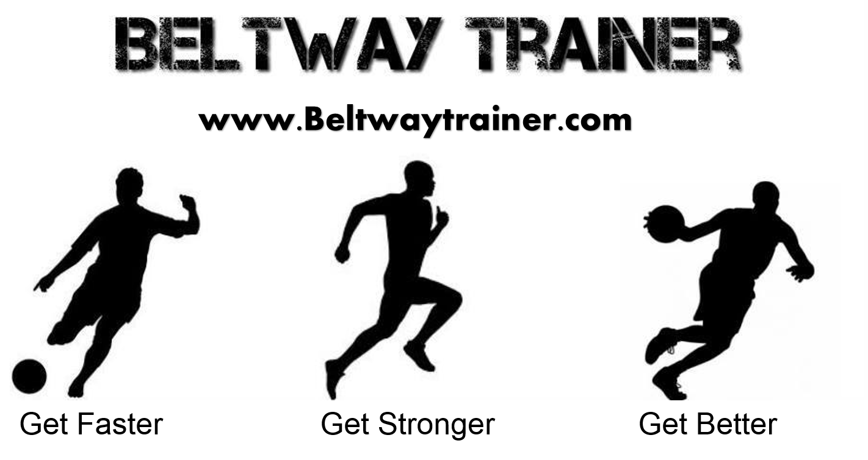

Client Contact Information:
Name:_____________________________________________
Phone (mobile):_____________________________
Full Address:________________________________________
In case of emergency, contact:____________________________________Phone:__________________________
General Statement of Program Objectives and Procedures:
I understand that this physical fitness program includes exercises to build the cardiorespiratory system (heart and lungs), the musculoskeletal system (muscle endurance and strength, and flexibility), and to improve body composition (decrease of body fat in individuals needing to lose fat, with an increase in weight of muscle and bone).
Exercise may include aerobic activities (treadmill, walking, running, bicycle riding, rowing machine exercises, group aerobic activity, swimming and other aerobic activities), callisthenic exercises, and weight lifting to improve muscular strength and endurance and flexibility exercises to improve joint range of motion.
Description of Potential Risks:
I understand that the reaction of the heart, lung, and blood vessel system to exercise cannot always be predicted with accuracy. I know there is a risk of certain abnormal changes occurring during or following exercise which may include abnormalities of blood pressure or heart attacks. Use of the weight lifting equipment, and engaging in heavy body calisthenics may lead to musculoskeletal strains, pain and injury if adequate warm-up, gradual progression, and safety procedures are not followed. I understand that Beltway Trainer shall not be liable for any damages arising from personal injuries sustained by _______________while and during the personal training program. __________________using the exercising equipment during the personal training program does so at his/her own risk. _________________ assumes full responsibility for any injuries or damages which may occur during the training. I hereby fully and forever release and discharge Beltway Trainer, its assigns and agents from all claims, demands, damages, rights of action, present and future therein.
I understand and warrant, release and agree that I am in good physical condition and that I have no disability, impairment or ailment preventing me from engaging in active or passive exercise that will be detrimental to heart, safety, or comfort, or physical condition if I engage or participate other than those items fully discussed on health history form).
I state that I have had a recent physical checkup and have my personal physician's permission to engage in aerobic and/or anaerobic conditioning.
Description of Potential Benefits:
I understand that a program of regular exercise for the heart, lungs, muscles and joints, has many benefits associated with it. These may include a decrease in body fat, improvement in blood fats and blood pressure, improvement in physiological function, and decrease in heart disease. I have read the foregoing information and understand it. Any questions which may have occurred to me have been answered to my satisfaction.

Signature of Client ________________________________________Date___________________
Signature of Witness______________________________________________Date___________________

